Good to Great Chapter 1

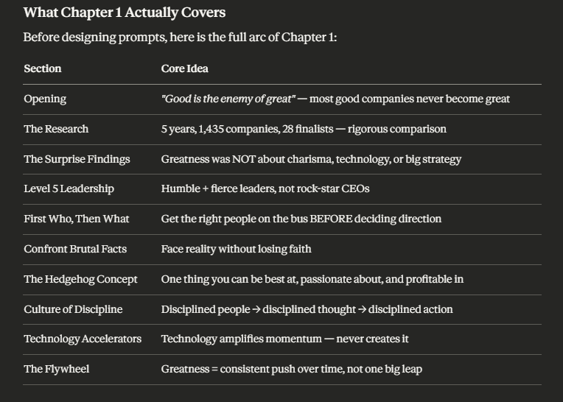

Speaking Output Prompts — 40 Minutes

Good to Great Chapter 1 (Full) | 12–15 Students Online

What Chapter 1 Actually Covers
Before designing prompts, here is the full arc of Chapter 1:
Section | Core Idea
Opening | "Good is the enemy of great" — most good companies never become great
The Research | 5 years, 1,435 companies, 28 finalists — rigorous comparison
The Surprise Findings | Greatness was NOT about charisma, technology, or big strategy
Level 5 Leadership | Humble + fierce leaders, not rock-star CEOs
First Who, Then What | Get the right people on the bus BEFORE deciding direction
Confront Brutal Facts | Face reality without losing faith
The Hedgehog Concept | One thing you can be best at, passionate about, and profitable in
Culture of Discipline | Disciplined people → disciplined thought → disciplined action
Technology Accelerators | Technology amplifies momentum — never creates it
The Flywheel | Greatness = consistent push over time, not one big leap

Structure Overview
0:00–0:12 Breakout Rooms (groups of 3) — Personal & Emotional Reaction
0:12–0:35 Full Group — Concept by Concept Debate
0:35–0:40 Closing Round — Every student speaks


⏱ 0:00–0:12 | Breakout Rooms — Groups of 3
Assign roles before sending out:
- Speaker A — answers first
- Speaker B — agrees or challenges
- Speaker C — summarizes + adds own view

Prompt -1
"Collins shows that Walgreens — a pharmacy chain that was completely average for 40 years — suddenly transformed and beat Intel, GE, and Coca-Cola over the next 25 years. Collins then immediately asks: why did Walgreens make the leap while Eckerd, in the exact same industry with the exact same opportunities, did not?
Here is the debate: Do you believe a company — or a person — can truly transform after decades of being average? Or is there a point where 'being average too long' becomes permanent?

Prompt 0 — The Eckerd Question (4 min)

"Collins gives us Walgreens AND Eckerd — same industry, same moment in history, same resources. One transformed. One didn't. What is your theory? What was the real difference?"

Emergency Prompts
"Walgreens beat Intel over 15 years. Did you know that before today? What does that say about what we pay attention to?"
"Collins says you can't just be lucky for 15 years. Do you agree — or can sustained luck exist?"
"[Name] — by Collins' criteria, is OctoLearn currently good, or great? Be honest."
"If someone studied YOUR life the way Collins studied these companies — what would their 'surprise finding' be?"

Prompt 1 — Your Gut Reaction
Display on screen before breaking out:
"Collins spent 5 years and studied 1,435 companies to answer one question: why do some companies make the leap to greatness while most don't? After reading Chapter 1 — what surprised you most? What did you expect the answer to be, before he revealed it?"
Why this works: Every student has a reaction. It rewards people who read carefully and gives a safe entry point for those who didn't.
Language target:
I'd been assuming that ___ before I read this
I was surprised that ___
I'd been thinking about ___ for a long time, but this changed it
Reporter brings back: The most surprising finding from their group's discussion.

⏱ 0:12–0:35 | Full Group Discussion
Use these in sequence. 4–5 minutes each. Always name someone — never ask the open room.

Prompt 2 — Level 5 Leadership
"Collins found that every great company had a 'Level 5 Leader' — someone who was deeply humble about themselves but fiercely ambitious for the company. Think of a leader you know personally, or a famous leader. Are they Level 5? Or are they the opposite — all personal ambition, little humility?"
Chat pulse first:
"Type the name of a leader you admire — anyone, real life or famous — GO"
Read 4–5 names aloud. Then:
"[Name] — you wrote [leader]. Are they Level 5 by Collins' definition? Why or why not?"
Chain from there.

Prompt 3 — First Who, Then What
"Collins argues that great companies first got the RIGHT PEOPLE on board — then figured out the strategy. Most companies do the opposite. Do you agree with this? Think about a team, class, or company you've been part of. Was the problem the strategy — or the people?"
Teacher anchor (30 sec):
"I once saw a team with a brilliant plan completely fall apart because of one wrong person. Have you experienced that?"
Call someone specific: "[Name] — in your work experience, was it ever a people problem disguised as a strategy problem?"

Prompt 4 — Confront the Brutal Facts
"Collins says great companies had the discipline to face brutal, uncomfortable truths — while still believing they would ultimately succeed. This is hard. Think about your own life or work — is there a brutal fact you've been avoiding? Something you KNOW is true but haven't fully faced yet?"
This is the most personal prompt. Give students a moment before calling anyone.
"Take 10 seconds — think of one honest answer. You don't have to share the real one if it's too private — you can give an example."
Why this works: It's vulnerable enough to generate real conversation, but the escape clause keeps the affective filter low.

Prompt 5 — The Hedgehog Concept
"Collins says truly great companies found the intersection of three things: what they could be THE BEST IN THE WORLD at, what they were deeply passionate about, and what drives their economic engine. Most companies only have one or two. What about YOU personally — do you know your own Hedgehog? What are you actually the best at, AND passionate about, AND can make money from?"
Chat pulse:
"Type ONE WORD — what are you most passionate about professionally? GO"
Read answers aloud. Then:
"[Name] — you said [word]. Can you turn that into a Hedgehog? Is there something you could be world-class at in that area?"

Prompt 6 — The Flywheel vs. The Doom Loop
"Collins describes the Flywheel — greatness is not one big dramatic moment. It's pushing consistently in one direction until momentum builds on its own. The Doom Loop is the opposite — constant change of direction, chasing trends, lurching from idea to idea. Which one do YOU recognize more in organizations around you? Which one do you recognize in yourself?"
Make it debate-worthy:
"[Name] said [company/person] is a Flywheel. [Other name] — do you agree? Or is there evidence of the Doom Loop there too?"

⏱ 0:35–0:40 | Closing Round — Every Student Speaks
Fixed order. Each student picks one sentence and completes it aloud:
"The concept from Chapter 1 that hit me hardest was ___ because ___"

"If I applied the Hedgehog Concept to my own life, my three circles would be ___"

"I've been operating in the Doom Loop when it comes to ___ — and I know it."

"If I could be Level 5 at one thing, it would be ___"
Rules:
- 20–25 seconds each
- No correction
- Teacher responds: "Strong." / "Honest." / "Exactly."
- Keep pace tight — this is closure, not discussion

🎯 Quick Reference Card for Teacher
━━━━━━━━━━━━━━━━━━━━━━━━━━━━━━━━━━━━━━━━━━━━━━━━━━━━
TIME PROMPT FORMAT
━━━━━━━━━━━━━━━━━━━━━━━━━━━━━━━━━━━━━━━━━━━━━━━━━━━━
0:00 Prompt 1 — Gut reaction Breakout
What surprised you most? groups of 3

0:12 Prompt 2 — Level 5 Leadership Full group
Who do you know like this? Chat pulse first

0:17 Prompt 3 — First Who Then What Full group
People problem or strategy? Teacher anchors

0:22 Prompt 4 — Brutal Facts Full group
What truth are you avoiding? Personal + safe

0:27 Prompt 5 — Hedgehog Concept Full group
What's YOUR three-circle Chat pulse first
intersection?

0:31 Prompt 6 — Flywheel vs Full group
Doom Loop — which do you Let it debate
recognize in yourself?

0:35 Closing round — one sentence Every student
per student, fixed order 20 sec each
━━━━━━━━━━━━━━━━━━━━━━━━━━━━━━━━━━━━━━━━━━━━━━━━━━━━


🛠 Emergency Prompts — If Energy Drops
"Type in chat: Flywheel or Doom Loop — which one is YOUR life right now?"
"[Name] — be honest. Are you a Level 5 person, or are you still building toward it?"
"If Jim Collins studied OctoLearn right now — what would he find? Good or great?"
"[Name] just said ___. [Other name] — is that a Hedgehog or a Doom Loop in disguise?"
"What's one brutal fact about your industry that nobody wants to say out loud?"

